**Bountiful Foods** is small business specializing in organic, locally grown foods. They are physically located in Carlsbad, California, however, they have many food trucks that cover the coastal area from Los Angeles to San Diego. The company sells fruits and produce directly from the farmers in the area, but also uses some national and international suppliers. The owner-operated company caters to walk in traffic at their storefront in Carlsbad and, of course, their food trucks. They deliver and manage those orders on the phone and via the website. The mission is to provide fresh and healthy food options, including organic, made to order, fruit drinks and fruit bags, to the local population and to tourists visiting the coastal areas. The theme should support healthy eating, organic bounty, and convenience.

**Site Name**

* Bountiful Foods

**Site Purpose**

Bountiful Foods is locally owned and operated specialty fruit drink company that has been supplying Southern California with delicious fruit drinks sense 2009. In addition to our storefront location, we have a drink wagon that you can visit for the same great drinks. Order on our website and pick up at either location. Or track our drink wagon from the website and find us there.

**Target Audience and Scenarios**

Bountiful Foods is here to target active adult women and men from 18 to 55 that maintain an active and energetic lifestyle. This main demographic is comprised of those that are obsessed with staying healthy and fit. Soccer moms and gym rats to cyclists and marathoners. From the pro athlete to those that just want to live better. If you need fuel for your meat machine, Bountiful Foods has you covered!

**Site Map**

**Home**

Site Nav

Summary info

Call to action

Social media links

weather card

specialty drinks Card

Last Modified

**About Us**

Historical Info

Contact Info

Google Map Location

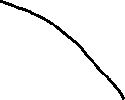

**Fresh**

Drink Order Form

**D**

**Resource page**

References

**D**

**Color Scheme**

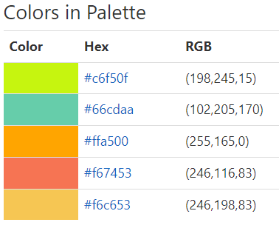

**Typography**

<link rel="preconnect" href="https://fonts.googleapis.com">  
<link rel="preconnect" href="https://fonts.gstatic.com" crossorigin>  
<link href="https://fonts.googleapis.com/css2?family=**Shadows+Into+Light**&display=swap" rel="stylesheet">

font-family: 'Shadows Into Light', cursive;

**Wireframe Sketches** (small, medium and large)

